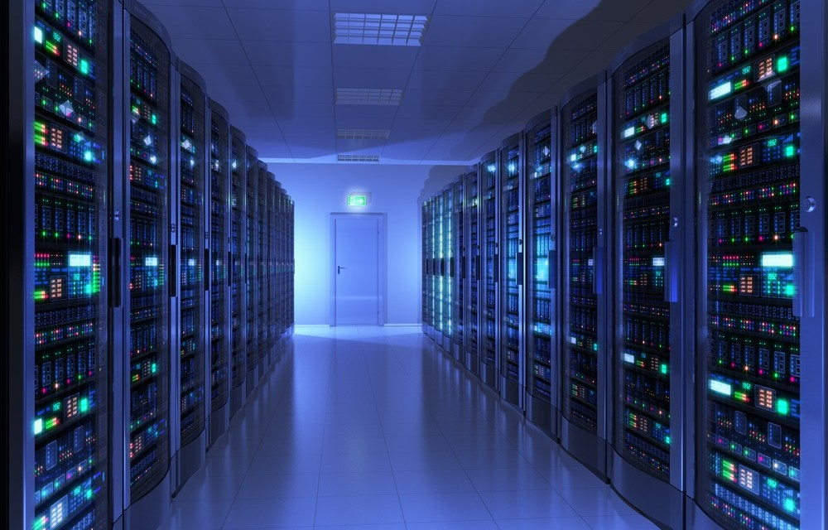

|  |
| --- |
| Secondary School Virtualization Final Report |
| 1. School Infrastructure IT Summary  Preferred Option |  2. Virtualization Implementation: Hyper-v  3. Hyper-v Costing Spreadsheet  4. Total Cost Analysis: Hyper-v  5. Final Infrastructure Topology: Hyper-v  Alternate Option |  6. Virtualization Implementation: ESXi  7. ESXi Costing Spreadsheet  8. Total Cost Analysis: ESXi  9. Final Infrastructure Topology: ESXi  10. Biography |
| Report by IntelliSyd Inc.  Authored by: Jack Sydenham |

# 1. School Infrastructure IT Summary

|  |
| --- |
| Currently, the South Melbourne Secondary College is falling a little behind with their IT infrastructure. Much of the hardware used in the school is currently outdated, or soon will be. While the school does make use of the government provided education software, their lack of provided student/staff personal work devices is underwhelming. The school also faces other problems, with no internal security for staff and students working within the school’s network, an ineffective use of physical devices such as servers running far below their maximum capabilities and driving up ongoing costs for an ineffective system. The school does have its upsides; memory has not been a problem as of yet, Wi-Fi connectivity and stability within the school is good enough for the school’s current size, and with the help of the Victorian government, an extra level of security is provided to the schools network through its eduProxy service. The Victorian government also helps by providing the school with the eduStar Standard Operating Environment for use by school end devices, allowing students/staff access to an excess of the latest teaching/curricular software.However of course, not all the upsides within the school will remain upsides as the student/staff population increases, and with covid pandemic in recent history, there is concern for the future of the schools curriculum. Turning to virtualization, the school will undergo an IT infrastructure overhaul in preparation for any future teaching situation, pandemic-related or not. There will be 2 Virtualization implementation solutions: Hyper-v and ESXi. Hyper-v is preferred as it offers more user flexibility than the ESXi solution for a cheaper price. |

# 2. Virtualization Implementation: Hyper-v

Both solution options utilize Server Virtualization, Desktop Virtualization, and Storage Virtualization to create a Virtual Desktop Infrastructure (VDI) on which students can connect to a Windows 10 based Virtual Machine (Running the eduStar provided curriculum image, customized to the schools wishes with specific applications chosen by the school) at any time, from anywhere, provided they have an internet connection. Students can then save their work to the virtualized storage pool, which allows them to access their saved work from another Virtual Machine at any time. This of course is also available to staff, who upon logging onto the VDI, will be assigned a Virtual Machine running the eduStar image that benefits them. This solution provides an increased level of security, manageability, and hardware/software utilization than the schools current arrangement.

Three new servers will be installed. Two of which will be clustered together using Hyper-v Failover Cluster to host the virtual machines accessible to staff and students. The third installed server will manage the old server services such as ADDS, DNS, DHCP, and Email in a more optimal way. A web server for students/staff to connect to the VDI will also be utilized out of one of the already installed servers, along with a connection broker server to dynamically assign users to various VMs based off their login request, ran from the other already installed server. The windows server then will act as a domain controller for the failover cluster of VM hosts.

The current routers within the school will be upgraded to both future proof and increase performance.

Switches in the schools infrastructure will be replaced with more up to date cisco units to future proof against their nearing end-of-support dates, along with adding a few new switches for new features like the implementation of a SAN.

The outdated Wireless Access Points and Wireless LAN Controller will be replaced with new, up to date hardware, capable of more connections in preparation for the projected increase in students over the next few years.

A Sophos Next-Generation Firewall will be installed within the network to ensure no unwanted data travels between the VDI and the rest of the network. The virtual machines will also be running Port-ACL, providing the ability to block incoming/outgoing traffic for virtual machines at the virtual NIC level. This allows ACL to be configured in such a way that VMs only look for a specific type of traffic, serving as a basic firewall for all VMs running on the network.

The physical end device set up will also be modified as a part of this solution, with students and staff receiving personal HP Chromebooks as work devices on which they can connect to the schools VDI if they do not have their own device. The Victorian government helps a lot with this, providing incredible savings on devices supplied for students, as long as they are paid for by the school. Of course for this, the schools BYOD system remains in place and available to all students and staff.

The great thing about Hyper-v is that with the help of a Windows 2019 Server Datacenter Edition, an unlimited amount of Windows based virtual machines can be licensed at no cost, and since the used eduStar image is based on Windows 10, all VMs running through in the VDI do not require licensing costs. Students and staff can log onto the VDI through their HP Chromebooks running ChromeOS and gain access to a Windows 10 based machine capable of running any and all applications that they may need for their work with no added cost.

The storage setup within the school will be upgraded by accompanying the current Synology NAS, holding student personal information, with another Synology NAS holding 96TB of storage. These two full NAS units will be merged into a pool of storage disks via a SAN. This SAN will allow enough space to accommodate the increasing amount of student personal information, create virtual disks to run the virtual machines, and store student/staff personal files created on the virtual machines. There will easily be enough space for each student to up to 10GB of personal work files on the storage pool.

Finally, the Uninterruptable Power Supply will be replaced with an APC UPS, accompanied by its PowerChute virtual agent, allowing safe, graceful shutdowns of VMs during the event of a power outage; very important to avoid long wait times between power outages and system reboots.

All software used here is approved by the Australian government. Although most used software is supplied directly by the government, VMware is actually used by the government as if they were a natural client. So obviously, this software is also approved.

3. Hyper-v Costing Spreadsheet

|  |  |  |  |  |
| --- | --- | --- | --- | --- |
| Equipment | Product | Item Price | Subtotal | Total |
| Server | Dell PowerEdge R540 x3 | $11,989 | $5,709 | $17,127 |
| Router | Cisco ISR 4331 x6 | $3,306 | $19,836 |  |
|  | Perfomance License x6 | $1,200 | $7,200 | $27,036 |
| Switch | Cisco SG350X-24 x2 | $1,732.50 | $3,465 |  |
|  | Cisco 2960x x12 | $1,156 | $13,872 |  |
|  | Cisco 9200L x3 | $1,233.50 | $3,700.50 | $21,038 |
| Wireless AP | Cisco Aironet 1832i x10 | $755 | $7,550 | $7,550 |
| WL Controller | Cisco 3504 WLC | $4,259 |  | $4,259 |
| Firewall | Sophos Next-Gen Firewall | $1,704 |  | $1,704 |
| Computers | HP Chromebooks x1,000 | $120 | $120,000 | $120,000 |
| Storage | Synology DS1821 NAS | $2,769 |  |  |
|  | Ironwolf 12TB Drive x6 | $525 | $3,150 | $5,919 |
| UPS | APC BX1500M | $200 |  | $200 |
| V-Software | Win Server 2019 DC Edition | $7,578 |  | $7,578 |
| Total |  |  |  | $212,411 |

4. Total Cost Analysis: Hyper-v

The total cost of the solution comes to $212,411 for a 13 week deployment. Being a relatively mid-sized budget, the hourly rate cost can be anywhere between $75 - $175. Since this solution’s time frame is a little more drawn out than the average virtualization deployment, with extra hardware being implemented to address a variety of other issues within the school, the expected hourly rate should be around $110, balancing between how much work is done to improve the IT infrastructure while remaining relatively affordable, and the drawn out length of the deployment.

5. Final Infrastructure Topology: Hyper-v

Routers

Border Firewall

internet

eduProxy Server

School’s LAN

Sophos Internal Firewall

Wireless LAN Controller

End Devices

Wireless Access Points

Failover cluster of 2 Dell servers

Windows Server

Connection Broker server to assign VMs

Web Server

ADDS, DNS, DHCO, and Email server



SAN (Virtual storage pool)

VMs running off cluster

NAS storage devices

# 6. Virtualization Implementation: ESXi

# This solution is similar to the Hyper-V option, in that it provides the school with a VDI capable of handling up to all the VMs needed to accommodate for students/staff working remotely. However there are some drastic changes that improve manageability for both the servers running, and the students/staff connecting to those servers. These drastic changes obviously reflect onto the total price of the solution, which should prove to be a strong deterrent, and provide reasoning to choose the Hyper-V solution over this one.

# Adding much more powerful servers than the Hyper-v option, this solution ensures there will always be an excess of processing power leftover for running VMs, and is capable of handling much more VMs than the school needs. The servers will be clustered together using vSphere High Availability, pooling the servers processing power for distribution to VMs as they are created.

# For the router replacement, a singular Brocade CER 2024C-4X will take the place of the current 10 routers within the schools network. Multiple schools in the past have opted for this with great success, replacing a multitude of routers on their campus with just one Brocade unit as a means of setting up a functional VDI for students and staff.

# The current switches will be replaced with the latest and greatest Cisco switches. Fourteen 2900 switches will replace the current 10. Much like the Hyper-v solution, more 2 more switches will be added to accommodate for newly implemented features like SAN.

# The same Wireless Access Points and Wireless LAN Controller that is used in the Hyper-v solution will be used here, as they provide all the necessary features and throughputs that the school will need to accommodate for the amount of students/staff using them.

# VMware offers the NSX Distributed Firewall, allowing VM resources to be isolated and segmented. Traffic policies can be enforced between segments, meaning if unwanted data is somehow able to enter the VDI, it won’t get very far before it is spotted and dropped.

# For the physical computer situation in this solution, BYOD will be abolished and HP Chromebooks will be provided to all staff and students. This allows the devices to be easily set up in the schools system, with students being assigned network approved devices in an orderly fashion. These devices can then be configured all at once by the school if any change is needed to be made to them.

# The Chromebooks are equipped with ChromeOS, which is compatible with the government provided Office 365 and Google Apps for Education. If students need to access any Windows based application they can simply log onto the Virtual Desktop through their Chromebook - provided they have an internet connection - and have access to any Windows application they need.

# Just as in the Hyper-v solution, the storage system will be expanded, adding another Synology NAS containing 96TB of storage, which will be pooled into a SAN accessible by the vSphere cluster for creating VM virtual disks and storing user work files. The increased storage also makes way for the projected increase in students and their personal information which will need to be stored.

# A CyberPower Line-Interactive Uninterruptible Power Supply will be installed to replace the existing UPS. Similarly to how the Hyper-v solution’s UPS comes with PowerChute for signaling servers to gracefully shutdown in the event of a power outage, CyberPower UPSs come with PowerPanel Business Edition, which achieves the same outcome of gracefully shutting down servers to prevent loss of data, errors when rebooting, and long reboot times. CyberPower UPSs are also optimized for use within VMware environments, making it a prime choice for this solution.

# As mentioned multiple times already, this Desktop Virtualization will run based off of vSphere. In particular vSphere Essentials Plus, which allows for High Availability clusterization of servers. To utilize High Availability however (along with more important features like live migration), vCenter Server Standard is also needed. Only one instance of vCenter is needed to cover all of the schools VM needs, allowing for running up to 2000 VMs. According to VMware, a VDI of the school’s scale (1500 students and 250 staff) is expected to run up to a maximum of 1400 VMs at any given time, so this 2000 VM cap is more than enough.

Much like the ESXi solution, all software used here - Even Hyper-v itself - is and approved by the Australian government.

7. ESXi Costing Spreadsheet

|  |  |  |  |  |
| --- | --- | --- | --- | --- |
| Equipment | Product | Item Price | Subtotal | Total |
| Server | Dell PowerEdge 9740 x4 | $11,989 | $47,956 | $47,956 |
| Router | Brocade CER 2024C-4X | $21,811 | $21,811 | $21,811 |
| Switch | Cisco 2900 x14 | $1,762 | $24,668 |  |
|  | Cisco SG350X-24 x2 | $1,733 | $3,465 | $28,133 |
| Wireless AP | Cisco Aironet 1832i x10 | $755 | $7,550 | $7,550 |
| WL Controller | Cisco 3504 WLC | $4,259 |  | $4,259 |
| Firewall | NSX distributed Firewall x3 | $4,500 | $13,500 | $13,500 |
| Computers | HP Chromebooks x1,750 | $120 | $210,000 | $210,000 |
| Storage | Synology DS1821 NAS | $2,769 |  |  |
|  | Ironwolf 12TB Drive x4 | $525 | $3,150 | $5,919 |
| UPS | CyberPower CP1500AVRLCD | $219 |  | $219 |
| V-Software | vSphere Essentials Plus | $4,625 |  |  |
|  | vCenter Server Standard | $6,175 |  | $10,800 |
| Total |  |  |  | $350,147 |

8. Total Cost Analysis: ESXi

The final price comes to $350,147 for a 10 week deployment. Like the Hyper-v solution, this implementation is a little drawn out, as there is a lot more to physically implement here than just the VDI. However it is almost a whole month faster than the Hyper-v deployment due to the streamlined setup that comes with VMware, and all students/staff using the one device, set up and configured directly through the school. With the final price being so high, and the deployment still taking 10 weeks. The hourly rate should not be expected to be past $100. Balancing between the high performance infrastructure that comes with this solution, and the already high upfront cost.

9. Final Infrastructure Topology: ESXi

Router

Border Firewall

internet

eduProxy Server

School’s LAN

Wireless LAN Controller

End Devices

Wireless Access Points

SAN (Virtual storage pool)

High Availability vSphere Cluster

Windows Server

ADDS, DNS, DHCO, and Email server



8 ESXi Hosts, all capable of running their own VMs for students/staff to access

10. Biography

<https://www.cisco.com/c/en/us/support>

[ENVEOLI1712010_V1.pdf (schneider-electric.com)](https://download.schneider-electric.com/files?p_File_Name=ENVEOLI1712010_EN.pdf&p_Doc_Ref=ENVEOLI1712010_EN&p_enDocType=End+of+life+manual)

[The Really Simple Guide to Hyper-V Networking (altaro.com)](https://www.altaro.com/hyper-v/simple-guide-hyper-v-networking/)

[VDI Implementation: It Doesn't Have to Be a Headache (g2.com)](https://www.g2.com/articles/vdi-implementation)

<https://www.reddit.com/r/Cisco>

<https://social.technet.microsoft.com/Forums>

[CyberPower Uninterrupted Power Supplies - Intelligent LCD UPS Systems (cyberpowersystems.com)](https://www.cyberpowersystems.com/products/ups/intelligent-lcd/)

[eduSTAR — ICT Services, Software and Advice for Schools: Policy | education.vic.gov.au](https://www2.education.vic.gov.au/pal/edustar-ict-services-software-and-advice-schools/policy)

<https://searchservervirtualization.techtarget.com/tip/vSphere-and-vCenter-licensing-and-pricing-explained-a-VMWare-license-guide>

[What is the function of a virtual switch in a VDI Infrastructure ? (parallels.com)](https://www.parallels.com/blogs/ras/virtual-switch/)

[BYOD brings its own challenges for schools and students (theage.com.au)](https://www.theage.com.au/education/byod-brings-its-own-challenges-for-schools-and-students-20150204-135p08.html)

[BAMITS - Information Technology Service provider Gippsland](https://www.bamits.com.au/case-studies/lavalla)

[Microsoft VDI Explained: Remote Desktop Services Virtualization (RDS-V) for Windows 2008 R2 & Windows 7 - Agile IT](https://www.agileit.com/news/microsoft-vdi-explained-remote-desktop-services-virtualization-rds-v-for-windows-2008-r2-windows-7/)

[VMware NSX licensing | Binary Maps](https://binarymaps.com/nsx/vmware-nsx-licensing/)

[Line-Interactive UPS Systems (vertiv.com)](https://www.vertiv.com/en-asia/about/news-and-insights/articles/product-class-articles/line-interactive-ups-systems/)

[The 5 Different Types of Firewalls Explained (techtarget.com)](https://searchsecurity.techtarget.com/feature/The-five-different-types-of-firewalls)

[Bridging the Digital Divide — Loaned School Owned Computers Support Initiative: Guidance | education.vic.gov.au](https://www2.education.vic.gov.au/pal/bridging-digital-divide/guidance)  
  
[VMware or Hyper-V? Part 3: Virtualization Licensing Costs - Longitude (heroix.com)](https://www.heroix.com/blog/virtualization-licensing/)

[What’s VDI? Virtual Desktop Infrastructure- Types of VDI- ITperfection, VM](https://www.itperfection.com/computer-network-concepts/whats-vdi-virtual-desktop-interface-infrastructure-connection-brocker-pcoip-rdp-daas-vmware-virtualization-citrix/)

[vSphere High Availability (HA) Technical Deepdive – Yellow Bricks | Yellow Bricks (yellow-bricks.com)](https://www.yellow-bricks.com/vmware-high-availability-deepdiv/)

[What to know for your virtualized storage selection process (techtarget.com)](https://searchservervirtualization.techtarget.com/feature/What-to-know-for-your-virtualized-storage-selection-process)

A variety of basic searches for products and their information were used but tracking all that were used is impossible. For example finding the amount of cores a server is equipped with.